Lebanon Valley College
Graduating Seniors Survey
Class of 2022: May Graduates

Methodology

This survey was administered to graduates of the class of 2022 starting April 20 through June 28, 2022. Graduates were first sent a web invitation through the e-mail on record. Reminders regarding the survey were posted regularly on the Lebanon Valley College Twitter and Facebook Groups. Of the 306 graduating undergraduate seniors, 128
completed the survey for a response rate of 41.83%

List of Sections
- Executive Summary……………………………………………………………………………………………………Pg.2
- Enrollment Plans.………………………………..…………………………………………………………………….Pg.3
- Employment Plans………...………………………………...……………………………………………………….Pg.4
- Reflection on Education – Participation………………………………………………………………….....Pg.5
- Reflection on Education – Growth.………………………………...………………………………………….Pg.7
- Reflection on Education – Job Search…..……………………………………………………………….......Pg.9
- Reflection on Education – Overall………………………………………………………………………….…Pg.11

List of Appendices
- Appendix A: Additional Enrollment Plan Information.……………………………………………..Pg.12
- Appendix B: Additional Employment Plans Information.………………………………………….Pg.14
- Appendix C: Internships Completed by LVC Students….…………………………………………..Pg.16
- Appendix D: Job Resources Used by Students..………………………………………………….…….Pg.21
- Appendix E: Commentary About LVC…………………………………………………………………….…Pg.23

Executive Summary
- A total of 27% of respondents reported having enrolled in a graduate or professional degree program, with the most common school provided being Lebanon Valley College. An additional 4% report having applied but not yet been accepted, again Lebanon Valley College being the most reported school applied to. A total of 18% of respondents reported having an accepted an offer for full-time employment, with an additional 28% reporting they have applied but not received an offer of employment.

- The modal reported annual salary of full-time employed respondents $70,000 or more (22%) followed by $65,000-$69,999 (17%). Approximately 83% of all respondents reported an annual salary wage higher than the national median net compensation of $34,612.04 per 2020 Social Security Administration data.
- For the question “to what extent did your LVC education and experiences contribute to your growth in the following area” and a scale of 0 to 4, the highest average response was for “Collaborate effectively with others” (3.12), followed by “Apply Knowledge” (3.11). The lowest average score was for “Understanding of a global society” (2.59) followed by “Preparation for a global environment” (2.60).

- The most common additional academic activity participated in by respondents was “Fieldwork, practicum, clinical experience, or student teaching” (58%) followed by “On-Campus Employment” (55%) and “Academic Support Services” (55%) The least common additional academic activity was “Multicultural fellowship program” (9%), “Study abroad” (10%), and “Other multicultural/diversity initiatives” (11%)
- Combined, 47% of respondents completed an internship, with 43% doing it for credit and an additional 4% completing them for no credit.
- A plurality of students did not visit the Breen Center (44%). Of those who reported using it (49%), a plurality reported using it only once a year (37%). Of those who reported using it, a plurality reported being satisfied (41%), with an additional 17% reporting being very satisfied. A total of 41% of respondents reported receiving other job search support, with the most common reported being their department or professor. Of these respondents, 40% reported being very satisfied with their support followed by an additional 37% reporting being satisfied.
- Approximately 73% of respondents report their overall experience at LVC as being Good (34%) or Excellent (39%). Approximately 56% report that they would “probably yes” (23%) or “definitely yes” (33%) choose LVC again if they had to start their college degree over again. Approximately 15% reported “probably no” (9%) or “definitely no” (6%).

Enrollment Plans

Please check the box that best describes your current enrollment plans for fall.

 | Number | Percent
Enrolled in a graduate or professional degree program | 35 | 27%
Accepted to one or more professional graduate degree programs but have not yet enrolled in one | 0 | 0%
Applying to one or more graduate or professional degree programs but have not yet been accepted | 5 | 4%
Enrolled in another Bachelor's degree or certificate program | 5 | 4%
Scheduled to complete student teaching | 0 | 0%
Taking classes but not toward a degree | 1 | 1%
Not enrolled in any courses and pursuing other opportunities such as employment, volunteer work, military, etc. | 66 | 52%
Other (Appendix A) | 5 | 4%
No Response | 11 | 9%
Total | 128 | 100.00%

Employment Plans

Please check the box that best describes your current employment plans.

 | Number | Percent
Accepted an offer for full-time employment | 23 | 18.0%
Applied, but have not yet received an offer for full-time employment | 36 | 28.1%
Have not begun applying, but plan to be employed full-time | 25 | 19.5%
Accepted an offer for or plan to be employed part-time | 5 | 3.9%
Participating in full-time volunteer service (e.g. - Peace Corps, Teach for America, etc.) | 1 | 0.8%
Serving in the military | 0 | 0.0%
Pursuing other full-time activity (please specify) | 24 | 18.8%
No Response | 14 | 10.9%
Total | 128 | 100.00%

Please indicate your annual salary range

 | Full Time Employment |  | Part-Time Employment
 | Number | Percent | Number | Percent
Unpaid | 0 | 0% | 1 | 20%
Below $24,999 | 1 | 4% | 4 | 80%
$25,000 to $29,999 | 2 | 9% | 0 | 0%
$30,000 to $34,999 | 3 | 13% | 0 | 0%
$35,000 to $39,999 | 3 | 13% | 0 | 0%
$40,000 to $44,999 | 3 | 13% | 0 | 0%
$45,000 to $49,999 | 1 | 4% | 0 | 0%
$50,000 to $54,999 | 4 | 17% | 0 | 0%
$55,000 to $59,999 | 5 | 22% | 0 | 0%
$60,000 to $65,000 | 1 | 4% | 0 | 0%
$65,000 to $69,999 | 0 | 0% | 1 | 20%
$70,000 or more | 1 | 4% | 4 | 80%
No Response | 2 | 9% | 0 | 0%
Total | 23 | 100% | 5 | 100%
Reflection on Your Education – Participation

Did you participate in any of the following while at LVC?

 | Yes | No | No Response
Study abroad or away program | 10% | 82% | 8%
Performance in student group (band, theater, etc.) | 29% | 63% | 9%
Performance or recital with faculty member | 12% | 80% | 9%
Publication in academic journal | 12% | 78% | 10%
Conference presentation with faculty member | 19% | 71% | 10%
Culminating project in capstone course or independent study (thesis, etc.) | 38% | 52% | 10%
Fieldwork, practicum, clinical experience or student teaching | 58% | 33% | 9%
Service learning with required reflection | 27% | 63% | 10%
Service learning as part of a course | 26% | 64% | 10%
Service trip | 12% | 78% | 10%
Athletics (intercollegiate team) | 34% | 58% | 8%
Athletics (club sport) | 15% | 74% | 11%
Academic support services (tutoring, writing center, etc. | 55% | 36% | 9%
Multicultural fellowship program | 9% | 82% | 9%
Other multicultural/diversity initiatives | 11% | 80% | 9%
On-campus employment | 55% | 38% | 8%
Leadership role (student government, residence life, athletics, peer mentor program, etc.) | 52% | 40% | 9%

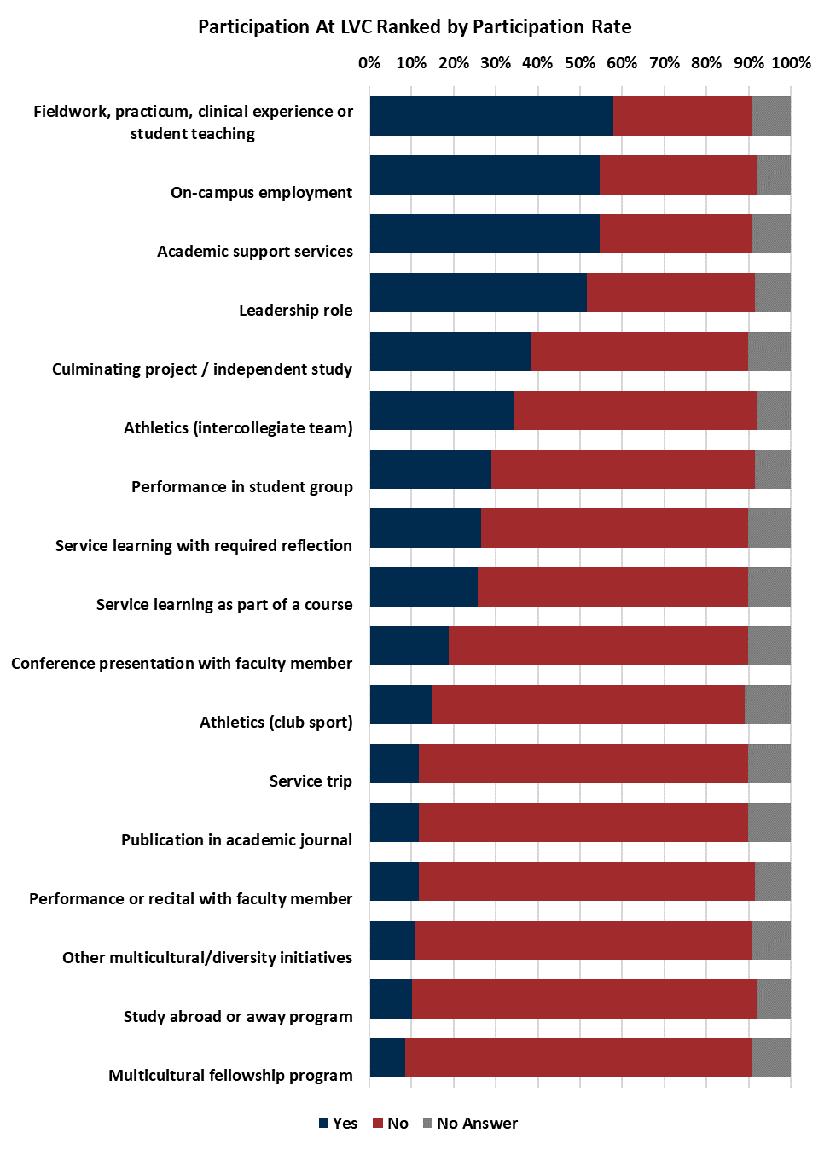
Reflection on Your Education – Growth

To what extent did LVC contribute to your growth in the following abilities:

 | Extre-mely | Very | Mode-rately | Slightly | Not at all | No Response | Mean
Apply knowledge | 31% | 37% | 10% | 5% | 1% | 16% | 3.11
Integrate knowledge | 25% | 41% | 11% | 5% | 1% | 17% | 3.03
Communicate effectively in writing | 30% | 27% | 20% | 5% | 2% | 16% | 2.94
Communicate effectively in speech | 29% | 32% | 17% | 5% | 1% | 16% | 3.00
Interpret representations of quantitative data | 21% | 31% | 23% | 5% | 3% | 16% | 2.75
Critically analyze information and ideas | 27% | 38% | 15% | 4% | 1% | 16% | 3.03
Design and implement problem solving strategies | 27% | 36% | 15% | 5% | 0% | 16% | 3.02
Determine credible, authoritative sources of information | 28% | 38% | 12% | 2% | 3% | 16% | 3.03
Understanding of a multicultural society | 20% | 34% | 19% | 9% | 1% | 16% | 2.77
Understanding of a global society | 15% | 33% | 23% | 10% | 2% | 17% | 2.59
Ability to make informed decisions | 27% | 38% | 13% | 3% | 2% | 16% | 3.04
Desire to participate in service to others | 24% | 30% | 20% | 7% | 2% | 16% | 2.80
Technological skills and abilities | 20% | 33% | 22% | 8% | 2% | 16% | 2.70
Value people who are different from yourself | 30% | 34% | 14% | 4% | 2% | 16% | 3.05
Collaborate effectively with others | 33% | 34% | 13% | 4% | 1% | 16% | 3.12
Preparation for a global environment | 18% | 30% | 22% | 10% | 3% | 16% | 2.60

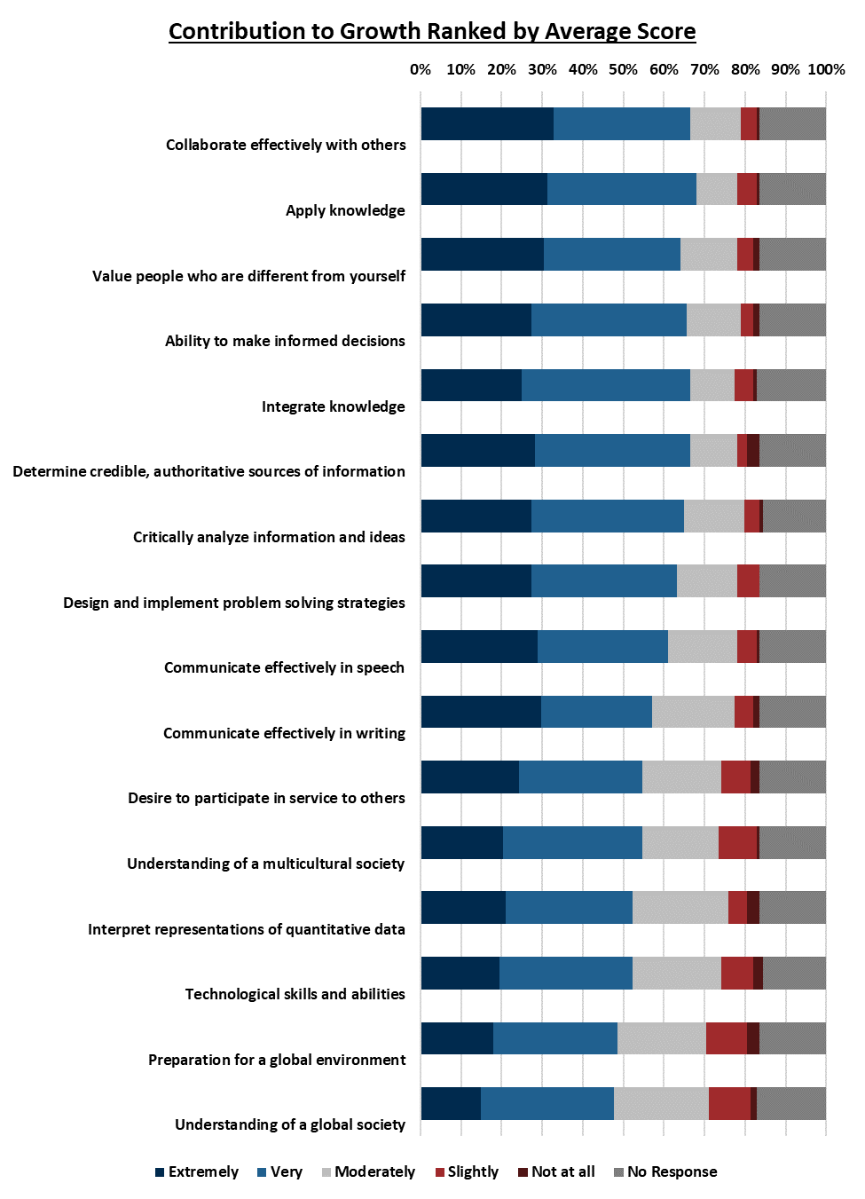
Reflection on Education – Job Search

Did you complete an internship while at LVC? (See Appendix C)

 | Number | Percent
Yes, for credit | 55 | 43%
Yes, for non-credit | 5 | 4%
No | 61 | 48%
No Response | 7 | 5%
Total | 128 | 100.00%

How often did you visit the Center for Career Development (i.e. Breen Center) at LVC?

 | Number | Percent
Never | 56 | 44%
Once a year | 47 | 37%
Once a semester | 12 | 9%
Once a month | 1 | 1%
More than once a month | 3 | 2%
No Response | 9 | 7%
Total | 128 | 100.00%

How satisfied are you with the job search help you received at LVC?

 | Number | Percent
Very satisfied | 11 | 17%
Satisfied | 26 | 41%
Neither satisfied nor dissatisfied | 18 | 29%
Dissatisfied | 3 | 5%
Very dissatisfied | 0 | 0%
N/A | 5 | 8%
Total | 63 | 100.00%

Other than the Breen Center, did you receive any other kind of job search support at LVC (ex: support from your department)? (See Appendix D)

 | Number | Percent
Yes | 52 | 41%
No | 65 | 51%
No response | 11 | 9%
Total | 128 | 100.00%

Reflections About Education – Overall

How would you evaluate your overall educational experience at LVC?

 | Number | Percent
Excellent | 50 | 39%
Good | 44 | 34%
Fair | 14 | 11%
Poor | 1 | 1%
Very poor | 0 | 0%
No Response | 19 | 15%
Total | 128 | 100.00%

If you could start your college career over again, would you choose LVC? (See Appendix E)

 | Number | Percent
Definitely yes | 42 | 33%
Probably yes | 30 | 23%
Possibly | 18 | 14%
Probably no | 11 | 9%
Definitely no | 8 | 6%
No Response | 19 | 15%
Total | 128 | 100.00%

Appendix A: Additional Enrollment Information

Other Responses to “Please check the box that best describes your current enrollment plans for all”:

Fulbright Grant
gap year then pursuing graduate degree
Pennsylvania State Police
Post-bacc biomedical research

Enrollment information for those who reported “enrolled in a graduate or professional degree program”

Institution | Program | Degree | Grad Date
Health Sciences | Speech-Language Pathology | Masters | 2023
Ichan Medical School in mount sinai NY | MPH | Masters | 2023
Lebanon Valley College | Athletic Training | Masters | 2023
Lebanon Valley College | Clinical Mental Health Counseling | Masters | 2024
Lebanon Valley College | Exercise Physiology | Masters | 2024
Lebanon Valley College | Intelligence and Security | Masters | 2023
Lebanon Valley College | Physical Therapy | Doctorate | 2024
Lebanon Valley College | Physical Therapy | Doctorate | 2024
Lebanon Valley College | Physical Therapy | Doctorate | 2025
Lebanon Valley College | Physical Therapy | Doctorate | 2024
Lebanon Valley College | Speech Language Pathology | Masters | 2023
Lebanon Valley College | Speech-Language Pathology | Masters | May 2023
Lebanon Valley College | Athletic Training | Masters | 2023
Lebanon Valley College | Physical Therapy | Doctorate | 2024
Lebanon Valley College | Physical Therapy | Doctorate | 2024
Lebanon Valley College | Physical Therapy | Doctorate | 2024
Lebanon Valley College | MBA | Masters | 2023
Lebanon Valley College | Physical Therapy | Doctorate | 2024
Lebanon Valley College | Physical Therapy | Doctorate | 2024
Lebanon Valley College | PT | Doctorate | 2024
Lebanon Valley College | PT | Doctorate | 2024
Lebanon Valley College | SLP | Masters | 2023
Lebanon Valley College | SLP | Masters | 2023
Millersville University | Clinical Psychology | Masters | 2025
Salus University | Physician Assistant | Masters | 2024
University of Toledo College of Medicine and Life Sciences | Medical | M.D. | 2026

Enrollment information for those who reported “Applying to one or more graduate or professional degree programs but have not yet been accepted”
Institution | Program | Degree | Grad Date
Lebanon Valley College | Clinical Mental Health Counseling | Masters | 2024
Lebanon Valley College | Intelligence and Security Studies | Masters | 2023
Penn State | PA program, Public Health | Masters
Youngstown State University | Music Performance: Conducting | Masters | 2024

Appendix B: Additional Employment Plans Information
Employment information for those who reported “Accepted an offer for full-time employment.”
Company | Position | City, State, ZIP
Amazon | Software Developer Engineer
Aon Consulting Firm | Actuarial Student | Radnor, Pennsylvania, 19087, USA
Blood bank | Hershey medical center | Hershey 17034
Buck Global | Actuarial Analyst
Carlisle Construction Materials | Sales Associate | Carlisle, PA 17013
Great Valley Publishing | Editorial Assistant | Spring City, PA, 19475
L3Harris Technologies | Image Science Engineer | Rochester, NY 14624, U.S.
Mary's | trainer
McKonly & Asbury | Staff Accountant | Lancaster, PA
Orthopedic Associates of Lancaster | PT Tech | Lancaster PA, 17601
Palmyra Area School District | Middle School Autistic Support Teacher | Palmyra, PA 17078
Pennsylvania State Police | Cadet
Trout CPA | Staff Accountant I | Lancaster, Pa, 17601, USA
Tufts University | Lab Technician
UNC REX Hospital | Medical Laboratory Scientist 1
WebFX | Remote Content Writer | Harrisburg, PA, 17102, US
Wellspan | Medical Technologist I | Lebanon, PA 17042
WPMT Fox43 | Digital Desk Producer | York, PA
York City Schools | Music Teacher | York, PA, 17401, USA
Youth advocate Program | Advocate and CTC | Lebanon, PA, 17046
ZooAmerica (Hershey) | Zoo Educator Aide

Employment information for those who reported “Accepted an offer for or plan to be employed part-time.”
Company | Position | City, State, ZIP
Home Instead Senior Care | Caregiver | Annville, PA, 17003, USA
Mary's Health & Fitness | Personal Trainer | Hershey, PA, 17033, United States
Sundress Academy for the Arts | Long-Term Writer in Residence | Knoxville, Tennessee, 37931
Youth Advocate Programs | Youth Advocate | Lebanon, PA

Appendix C: Internships Completed by LVC Students 2021-2022

Internship information for non-credit internships
Company 1 | Position | Company 2 | Position | Company 3 | Position
Amazon | Softaware Developer Engineer Intern
Buck Global | Actuarial Intern | Cumberland Mutual | Actuarial Intern
Gen Z Publishing | editor
Hershey Entertainment & Resorts | Reservations Agent
LVC | SummerResearch Assistant

Internship information for for-credit internships
Company 1 | Position | Company 2 | Position | Company 3 | Position
Annville - Cleona Veterinary Associates | N/A - Job Shadowing | Veterinarian Medical Center of Lebanon, Inc. | N/A - Job Shadowing
Annville Public Works | Observer, Wasterwater Treatment
Aon Consulting Firm | Actuarial Intern
Bell Nursery | Internal Communications
Boger Concrete / Byler Holdings | Intern
Carl Bahner Music | Music Producer
Carlisle Construction Materials | Sales Associate
Degy Entertainment | Marketing Intern
Drayer | SPT | Mary's Health and Fitness | Trainer
Drayer Physical Therapy | Student
Federal Trade Commission | Intern - Bureau of Advertising Practices
First United Methodist Church | Audio and Media Intern
Friends of Old Annville | Archival Assistant
Greg McCauley for Congress | Berks County Campaign Coordinator | Trump Victory Campaign | Region 9 Intern | Greenlee Partners | Intern
H2O Happiness 2 Others | Social Media Coordinator
Hershey medical center | Lab technician
Home Instead Senior Care | Caregiver | Sexual Assault Resource and Counseling Center | Intern
IU-13
Knoebels Amuesement Resort | Marketing/HR Intern for Employee Engagement and Retention Initiatives | IAAPA (not for credit) | Showfloor Ambassador - specialty: PR and marketing
Lancaster County Parks and Recreation Education Group | Intern
Lebanon County Correctional Facility | Correctional Officer
Lebanon School District | Business Office Intern | Volunteer Income Tax Assistance | Scheduler | Trout CPA | Accounting Intern
Lebanon Valley College | Student Office Assistant Intern
Lebanon Valley College Office of Marketing and Communications | Intern
LIU:11 | student volunteer
Lvc athletic communications | Intern
LVC Strength and Conditioning | Intern
Myerstown First Aid Unit | intern
non profit tennis organization | website and social media
NovaCare Rehabilitation | student physical therapist
Palmyra School District | Accounting Intern | Simon Lever | Accounting Intern | McKonly & Asbury | Accounting Intern
Phoenix Physical Therapy-Frackville | Student Physical Therapist | Phoenix Physical Therapy-Robesonia | Student Physical Therapist
ritchey Metals | Human Resources
Sexual Assault Resource and Counseling Center | Hotline Operator | Youth Advocate Program | Advocate
Snyder PT | Student
South Lebanon Elementary | K-5 general music teacher/chorus teacher | Lower Dauphin High School | High School Chorus/Music theory teachef
Southwest Elementary School, Lebanon School District | Student teacher
Spooky Nook Sports | Sports Performance Intern
Student Teaching | Teacher
Sundress Academy for The Arts | Remote Editorial Intern | Berks County Living Magazine | Remote editorial intern
UPMC Cardiac Rehab | Exercise Physiologist Intern
Vista School | Observing
Vista School | Student clinician
Walkers wine and spirits | Ownership/ high management role
Walz Group | Tax Intern | LVC | Business office/AP/ audit intern | Simon Lever | Intern
WNC CPAs & Consultants | Tax Intern
youth advocate program | advocate
Youth Advocate Program | Youth Advocate
Youth Advocate Program | Youth advocate

Appendix D: Job Search Resources Used by Students

Advice and recommendation letters for Graduate school from academic advisor
Advice from advisor and faculty
Advisors
Assistance from Student Advisor, Dr. Patton.
BIO + NEURO depts
Biology
Capstone Course
Department
Department
Department chair sends open position to people in major on daily basis
Department head forwards us job opportunities
Departmental
Departmental Support, mainly from Dr. John Hinshaw
Dr. Urban sends job opportunities as they arise.
Education
Emails about job opportunities
emails from department
Enrollment in job fair
Football coaches sending out job offers
Help from the chemistry department
I met with various faculty from the English department multiple times, and they were all extraordinarly helpful
I would receive multiple emails from staff members in the department (manza, marx, mcfalls) about upcoming internship and possible employment opportunities.
Jeff Snyder - Music Department - resume help
Job Postings and Information about Certification Tests
Job/internship opportunities emailed out by the head of the English Department
Kelsea Gonzales
LVC math sciences career fair
Millersville Job Fair
My internship supervisor helped me to find jobs close by that I would be able to apply for.
Part of our final seminar course was to discuss and start our PAReap accounts.
people i know from home and my professors
Political Science Dept.
Postings from our Director as well as links to teaching websites
Professional development class
Professors
Professor's advice
Professors connected me to industry professionals
Professors were very helpful, Capstone class offered a variety of job search opportunities
Recommendations from professors, etc.
Senior Capstone and Student Teaching Seminar
Spoke with Dr. Manza about opportunities after graduation
Support from capstone class with kelsea
Support from department
Support from music department, family
Support from my advisors
Support from professors/advisors.
Teachers
the accounting department helped me find internships
Yes - from a professor in the English department.

Appendix E: Commentary About LVC

Comments from respondents who answered “probably yes” and “definitely yes” for “If you could start your college career over again, would you choose LVC?”
Based on everything above I feel as thought LVC played a huge role in letting me achieve these abilities and skills
Because I attended a great program and was a part of a great swim team.
Classes and enviroment
Cost considerations
During my time at LVC, I felt that my contributions were valued and that I was respected both by my professors and my peers. I also enjoyed the small school environment, as I felt that my professors took the time to get to know me, which you often do not get at a larger school.
Fantastic school, beautiful campus, great staff and students, and excellent location.
For the same reason I chose it in the first place - the 3+3 physical therapy program. It is the only one in the area, and it is extremely beneficial to be accepted as a freshman into the graduate program.
Good, small school with high student to professor ratio. Makes conversation, lecture, and debate more powerful.
I always felt like more than a number in my classes here. The professors are all very personable and always take time to connect with students on a personal level, which I greatly appreciated. The English department is amazing!
I am able to stay home and be a commuter. This allows me to work part-time and travel to and from school everyday.
I ended up having to transfer because I needed specific classes to go to a physician assistant program, so starting at LVC would have prevented the need for a transition.
I got a job after
I had so many opportunities offered to me at LVC and I was able to thrive during my time here. I would definitely choose LVC again. My only complaint is the food.
I have worked for the college all three years that I have been here and have enjoyed learning more about the campus and truly getting experience in working for higher education.
I love LVC
I love LVC. I am a Valley Ambassador, tutor, English department student representative, and athlete. Every time I say I love LVC I mean it. I have grown so much as a student, athlete, and person. LVC taught me what I am capable of and given me amazing memories. Most importantly, LVC has equipped me for life after college.
I love the education I am receiving but I have had a few bad experiences with faculty that make me think LVC does not care about its students more than the money they bring.
I love the education, but sometimes the social life at LVC is hard. It is important to balance work/school and social/personal life. I feel many students would rather go to bed early on a Friday and Saturday so they can get up early and work on homework. I have a couple of friends who have the same outlook on life as I do when balancing work and life, but I feel we are outliers. Working hard is essential, but so is taking care of yourself and enjoying life. I also feel like this campus encourages a privileged mentality. Other than that, I love LVC and my coursework. I feel very strong and confident in my work and feel I know how to use the tools to continue to improve.
I loved my time at LVC. I met so many people, I had so much fun, the Education Dept is amazing. My professors are now my friends, they have helped me so much and prepared me for my next steps. I have truly loved being a part of this community and will miss it very much.
I most likely would have because I believe LVC has truly prepared me well for graduate school, however, I may have considered other colleges or universities simply because LVC is a very expensive school and I am paying for school myself.
I would choose LVC again because it is clear that the professors are understand the material and the genuinely care about all of their students. I have learned so much at LVC and I am incredible thankful for this experience.
I would choose LVC again because of the large opportunities I got professional development from such a small school, and the small classroom type education I got as well.
I would choose LVC again if I were to start my college career over because I loved the atmosphere, the people I have met here, and the faculty.
I would choose LVC due to the amazing opportunities I have received, the friendships I have made, and the preparation for my future career that would not have been possible if I did not enroll at LVC.
I would still choose LVC because I enjoyed the small campus environment and the feeling that my professors and coaches cared about each individual student as a whole.
It felt like home
It fit the criteria I was looking for to balance sports and school.
It’s close, the tuition is cheap for me due to the scholarship, the classes are small, and I met people here who changed me for the better.
LVC allowed me to engage in opportunities outside of my major, such as music ensembles. It also allowed me to apply the knowledge/skills I learned in my classes to my interactions on campus, especially in my clubs and activities. Overall, I felt that the small community environment helped me to build valuable connections between myself and colleagues/professors which I greatly appreciate.
LVC has provided me with so many different opportunities, whether they've been academically or within extracurricular activities. I joined the swim team and was a part of my first team sport, trying a sport I had never done before. It was a great experience.
LVC helped me grow significantly as a person in many different ways
LVC was an amazing school. It felt like a family, especially in the music department and I loved that.
LVC was the right fit for me in terms of the recording program and the growth I achieved
Met amazing people, earned leadership opportunities, exposed to new environment, learned about myself and others. Made endless memories, created bonds with faculty, prepared for life post-LVC.
Overall, I enjoyed my time at LVC. When I look back at the person I was when I graduated high school, that is not the same person that I am today. I have learned a lot in the classroom, as well as practically from my experiences at LVC.
The community created at LVC is all connected. While being in the music department, I did not realize how many people I know and the impact that each person would have on my life. I often call LVC my little family. When I think back to where I was 5 years ago before coming to LVC, I realize the necessity of that familial bond that I did not have before. I have grown as a person, a motivator, a leader, and most importantly a teacher.
The English department is the most amazing and supportive place to learn ever, but the broader campus has some issues, especially with hate speech.
The multiple opportunities that are availble.
There are many great opportunities at LVC both academically and socially. The environment is very welcoming, which is what initially drew me to LVC in addition to the PT program.
Was a little too close too home.
We need more diversity.
Why: Great music program, teachers really care
Why I wouldn't: Constellation LVC, it is by far the worst experience I went through here at LVC

Comments from respondents who answered “possibly”, “probably no” and “definitely no” for “If you could start your college career over again, would you choose LVC?”
Aside from the friends I made, campus life was pretty miserable. Awful food, no fun, poor living conditions.
Could have got the same education at another college. Too overpriced and can definitely improve. Lots of classes I had, professors were no help when I had questions or concerns.
Excellent education, its just not the most exciting area to be in.
Finances
-Great experiences outside of college
- LVC gives a bunch of opportunities for students to succeed
- I would choose a different sport because I did not receive the experience I thought I would for 4 years
- LVC curriculum is too broad (FYE&lt; Companion, exct.) I would rather just take classes that would help me in my major
I most likely would not have chosen LVC for the neuroscience program due to the lack of neurosciences classes. Additionally, I think it is extremely unfair for particular majors to "gate keep" and restrict students from taking necessary courses simply because they are geared toward another program. For example, many students must take anatomy and physiology for graduate schools. Biology/Neuroscience students must separate these classes into "Mammalian anatomy" and "human physiology"--many graduate schools do not accept this so students are left to take this course at another school. This is unreasonable when the exercise science program has an anatomy and physiology course but it is restricted to those students only (even when all pre-requisites are met). Additionally there are very few neuroscience based classes--the majority are psychology or biology based--however the SLP program offers a neuroscience course that is again restricted to only those on the SLP track. The neuroscience program has such little attention drawn to it and it seems that the school shows favoritism within programs.
In addition to the education aspect, I think that the director of resident life and public safety is not truly concerned about their students. I have personal experience with feeling threatened and unsafe in my own dorm and I made reports to both resident life and public safety. Resident life insisted that my roommate was not at fault because "she cried" so she must "feel bad" after I was threatened and harassed by her (she specifically targeted my eating/mental health disorders, which shows lack of inclusivity and tolerance), while I never once threatened or harassed her. Meanwhile, public safety never followed up on the issue or ensured my safety. I feel that it is a major flaw if the school does not take reports seriously. If the situation would have escalated further, the school would be at fault for not protecting their students.
I really liked the professors and faculty in my department and would choose them again instantly were I to complete college again. I felt that they cared about my education and my life after graduation and tried to prepare me for the real world. I do not feel this way about the administration of this school, though it is difficult for me to know if this is an LVC issue or simply the culture of higher education administration.
I think that LVC offers great support in certain areas (my English department and professors offered a wonderful experience) however I do no think that LVC cares about the Humanities department as much as they do about their STEM majors, PT majors, etc. The experience at LVC was overall positive, but it was due to the English professors and the friends I met, not necessarily because of the college admin.
I wish I stayed closer to home, I feel like I didn’t mesh well with the type of students that were in attendance.
I would choose LVC for the academics, but the social life is lacking.
I would not choose LVC again because of the improvements the college needs to make. It is evident that some aspects the college lacks are trying to improve (diversity, accessibility resources), but others are not. As a commuter, attending LVC is painful. As a freshman, I had to arrive over an hour early to my class to find parking in the commuter parking lot (it was not explained to me that I could park in residential lots, as the lots are/were marked as residential parking only). Then spaces were removed for the bridge, making even less parking available, especially during construction. Additionally, having a huge tent (that I rarely see used) takes up even more parking. Similarly, it was difficult to participate in campus events due to their times. Despite the difficulties of being a commuter, I've heard horror stories about living on campus and thus would not choose to live on campus. Additionally, the response to the COVID-19 pandemic was poor (giving residents very little time to move out, inaccurate contact tracing, lack of accuracy in the COVID dashboard); LVC's response emphasized that money was a primary factor in the decisions that were being made. On a positive note, I believe that the professors are great people and value their students.
I would not choose LVC because my major would be in electrical engineering, mechanical engineering or computer networking and LVC does not have those programs.
I would probably go to a more diverse place if I could start over again.
I would weigh out the options with each school and pick carefully.
If I had applied as an SLP major to other colleges before making a decision. I was originally going for education and only applied to two as SLP. This limited my choices.
Im local and commuted all 4 years. I would've rather had the authentic live on-campus experience far from home
It's difficult to say because overall, the classes related to my degree were super helpful in my development for the field I am going into, but the other courses that weren't related to my degree such as connective, immersive, language, etc. were not very beneficial for my development. For example, since I am an Audio and Music Production major, I really had no need to take 2 semesters of a language because I am not going to use it in my field. The same could be said about my connective, I learned about adolescence, but I'm not going to be working with them. I feel like the time I spent in classes like those could have been spent on more classes related to my degree, because even parts of those classes felt rushed and couldn't cover everything necessary to learn because there wasn't enough time to teach it all due to other classes. Plus, I don't feel very prepared for other parts of post college life such as knowing how to pay my taxes or pay rent for an apartment, which I sort of learned in high school, but haven't gone over in more than 4 years and have honestly forgotten how to do because I have been so worried about doing research papers and presentations which have nothing to do with post-college life.
LVC was a small enough campus that I was able to participate in research for the three total years that I have been here. It is a result of this research that I had a tangible experience to talk about during my job interviews, and I firmly believe that without that experience, I would not have been extended an offer, let alone an interview opportunity. For that, I am thankful that I have been given the opportunity of a personalized experience.
On the other hand, the LVC sciences are rather small compared to larger universities and begin to lack some of the more advanced features that universities with grad school programs offer. I understand this is a battle of balancing a budget and feasibility, but a prospective student accepted into multiple universities will not see it that way. Science fuels creativity, and it would be so cool to see a campus bustling with physics students that are provided resources to engage that creativity.
I've also been able to graduate in the matter of 3-years by taking a summer course at HACC. Many more students could graduate in 3, even 2-years if the liberal arts part of the degree was nixed or reduced. While I found one of my connective courses and one of my FYE courses to be super insightful, and I would recommend them to future students, I did not feel challenged in my writing, academic source searching, or expression and critique of an open talk. Additionally, the liberal arts degree is not visible on a resume or application, more so in how we present ourselves, which could be taught in manners other than a constellation experience. Imagine the attractiveness of a degree from LVC if students could save up to 2-years (more likely 1) of tuition and still graduate with a competitive degree. There is no reason why this could not be done, and it would be so cool to see it made more possible/available!
LVC’s academic schedule and courses were actually pretty good and challenging. But they definitely do not out weigh the challenges and bs a student has to put up with outside of the academic world. I feel as though the housing selection is extremely biased towards kids that state they have mental issues and get a doctors note and it just reinforces their already over inflated sense of entitlement. The fact that parking is almost zero on campus and you have to register your car and you have to pay each semester is bs as well let alone I park outside my off campus house and get a police ticket because the school reported me for not registering my truck with the school is bs as well. The off campus and outside the class room atmosphere of this school is a joke and definitely out weighs their in class performance.
Not saying this school is bad academically, but I would've choose a different school based on academic rather than for athletics.
Only thing that kept me here was my friends and the fact that private institution's credits are harder to transfer than a state school's.
Pretty much every student I know agrees that this place is awful. School looks for any opportunity to fine students and collect more money, and openly attempt to deny students any attempt at social gatherings. I would never advise anyone to come here, it was a huge mistake.
price
The administration blatantly does not care about athletics and would rather not have an athletics program, which is a huge smack in the face to student athletes. Student athletes make up over 50% of the student population so I don’t know why administration would not want to put time and resources into developing a better program. If the administration doesn’t care about athletics, the athletics program won’t be as successful, and school pride will be nonexistent. No one is proud to go to LVC, we all either chose it because it was 1) close to home or 2) we’re doing a graduate program. Invest in what your students care about, and they’ll care about the school.
the masks and LVC not being reasonable with their policies. these last two years were not fun and lvc could do better.
Too expensive even with aid and scholarships.

“Average Wages, Median Wages, and Wage Dispersion.” Ssa.gov, 2022, www.ssa.gov/oact/cola/central.html.

