This guide aims to familiarize you with the basics of Microsoft Teams Phone and Calling. If you have any questions or need further assistance, please contact the IT Solutions Center at solutions@lvc.edu or call 717-867-6072.
Microsoft Teams Phone Reference Guide
Microsoft Teams allows users to securely make and receive phone calls on any device using their LVC-assigned phone number. Before you can make or receive calls in Teams, you must ﬁrst log in with your LVC email and password. You can use Teams through the desktop app on a computer, the app on your mobile device, or via the web in Microsoft 365 Copilot (https://m365.cloud.microsoft).

Making a Call
Once you’re logged into Teams, ﬁnd the Calls button on the left navigation.
The keypad allows users to make calls by typing the name of an LVC employee, dialing a 4-digit internal extension, or entering any 10-digit phone number, and then pressing Call.
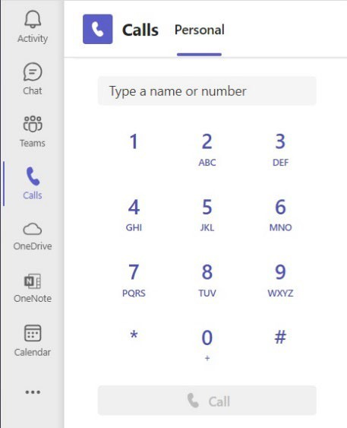
Your work number (the phone number that will appear as the caller ID and your direct line) is displayed under the Call button.
Other ways to make calls include hovering over someone’s proﬁle picture in Teams or Outlook and clicking the phone icon or tapping the audio call button at the top of a Teams Chat conversation. You can also initiate a call from your call history or by choosing one of your Speed Dial contacts.
To ﬁnd the four-digit extension for another LVC employee or department, please refer to the LVC website or the MyLVC directory. All full-time employees with a college computer are assigned an LVC phone number, along with some part-time employees as necessary. If someone does not have a phone number, please contact their department admin to reach them.

Speed Dial
Setting up speed dial saves time by keeping your frequent contacts at the touch of a button. The speed dial menu is located on the right side of the Calls page in Teams. To add a contact to your speed dial, click the add person icon and type in the number or name of the person you want to add. They should appear on the menu, allowing you to call them simply by clicking on their name. This speed dial menu will sync across any device you use for Teams Calling.

Receiving a Call
When someone calls you, you'll receive a notiﬁcation that allows you to accept or decline the call. Please note that you can only receive calls if you are logged into Teams, and all devices that are logged in will ring.

- Select to answer with audio only.
- Select to answer with audio and video.

- Select to decline the call.

In-Call Options

Dial Pad: Show the dial pad if you need to dial an extension or answer menu options.
Hold: Place a call on hold. Continue by selecting Resume. Calls on hold cannot be transferred.
Transfer: You are given the option to Transfer or Consult then Transfer.
Choose Transfer to send the call straight to the recipient.
Choose Consult, then Transfer to speak to the recipient or message them before handing
off the call.

Chat: To view the Chat (if there is one) between members of the call.
People: To view the People in the call, and be able to invite others, up to 50 participants.
Note: if a person is added, a new chat is created. They cannot see your previous chat.
View: Changes the screen view of the call.
More: Under this, you can ﬁnd options to record and transcribe, call settings, and more.
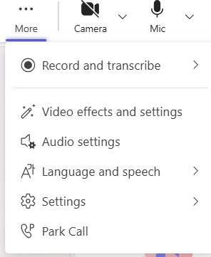
Camera: Toggle this on and off to show video. The v menu toggles through camera options.
Mic: Toggle this on and off to mute audio. The v menu toggles through options.
Share: Use this to share your screen or window, or collaborate on a document or whiteboard.

Presence Status
It is important to understand what presence status means when making a call or managing your own status. In Teams, next to a person’s proﬁle circle, there is a symbol. This symbol reﬂects user activity (Available or Away), the status of the Teams app (In a call or Presenting), and their Outlook calendar (In a meeting). A user who isn’t logged into Teams on any device is considered Offline. This status can be set manually by clicking on your proﬁle circle in the top right corner of the Teams window, or by setting an Out of Office message in Outlook to send automatic replies. If a status is set manually, you must update or reset it for it to revert back to automatic adjustments based on your information.

Icon | Meaning
 | Available
 | Available, Out of office
 | Busy, In a call, In a meeting
 | In a call, Out of office
 | Do not disturb, Presenting, Focusing
 | Away, Be right back
 | Offline, Status Unknown
 | Out of office

Customizing Settings, Voicemail, and More
Select next to your proﬁle picture at the top right, and choose Settings > Calls .
Here, you can customize your Teams Phone experience. Read through the menu options and choose what works for you.
Call Handling and Forwarding: From here, you can forward all calls, like if you’re going to be out of the office, and you can set how you want your calls to come through, what to do when you can’t answer, and how many seconds the phone should ring before redirecting. This is also where you’ll choose your ringtones.
Manage Voicemail: You can record a custom greeting, use a default greeting, or set up a text-to-speech custom greeting.
Manage out-of-office Voicemail: You can choose when an out-of-office greeting should play and a custom greeting.
Manage call group: Call group members can receive calls on your behalf. When your phone rings, their phone will also ring, and they can answer.
Manage delegates: Delegates can make and receive calls on your behalf.

Receiving Voicemail
You can check your voicemail in several ways. You will receive an email containing an audio ﬁle of your voicemails along with a transcription, if available. Voicemails can also be accessed from the Calls screen in Teams by selecting the drop-down menu in call history.

Please direct any questions or training requests to the IT Solutions Center at 717-867-6072 or solutions@lvc.edu.

