Carbon Footprint 2010-­‐2011
During the 2011-­‐2012 school year, a carbon inventory was completed for the 2010-­‐2011 fiscal year. In the program this is designated as 2010-­‐2011 Report. The program breaks down emissions into three categories: Scope 1, Scope 2, and Scope 3.

Scope 1 emissions are direct emissions that come from sources that are owned and/or controlled by Lebanon Valley College. LVC has complete control over these emissions such as the fossil fuel combustion of campus fleet vehicles. These are the direct responsibility of the college. Scope 1 emissions for LVC result from fossil fuel and fertilizer usage. The campus uses natural gas and distillate oil for heating buildings; most buildings use natural gas. Diesel fuel and unleaded gasoline used for running the college fleet also fall into the scope 1 category. Refrigerants and other chemicals would be another source of scope 1 emissions, but the college ensures that these chemicals are properly cared for and not released as emissions.

Scope 2 emissions are indirect emissions from sources that are not owned or operated by Lebanon Valley College. However, these sources are directly linked to the energy used by the campus. While the college is not of direct responsibility of these emissions, it is the fault of the college for the need for these emissions due to demand. For Lebanon Valley College, purchased electricity is the only source of scope 2 emissions. The monthly records for electricity purchases is available from the office of Facility Services and is also among the publicly available spreadsheets provided in the department’s public drive.

All other emissions are attributed to the Scope 3 categories. These emissions are typically considered as “optional” and are harder to classify. Either these emissions are the result of direct financing or encouragement of the college, but are not from sources owned or operated by LVC. Some great examples of this would be study abroad travel and faculty, staff, and student commuting. The responsibility of these emissions is unclear, but must be carefully monitored in order to ensure the emissions are not counted twice.

After gathering all the necessary data, the Campus Carbon Calculator was used to analyze the emissions produced by Lebanon Valley College

CARBON INVENTORY RESULTS SUMMARY
Before any mitigation strategies, the total 2010-­‐2011 emissions for all 3 scopes were 10,416.5 MTeCO2. Figure 1 shows the breakdown of emissions by scope, but Figure 2 shows a more detailed breakdown. It appears Scope 2 is the most significant contributor to our total emissions according to Figure 1. Figure 2 shows purchased electricity is the most significant contributor to our total emissions, which is the sole component of Scope 2 emissions. In addition to our usual figures in

other reports, this year we have added two additional figures. Figures 3 and 4 show the progress we have made since 2008.

Figure 1: 2010-­‐2011 Emissions by Scope

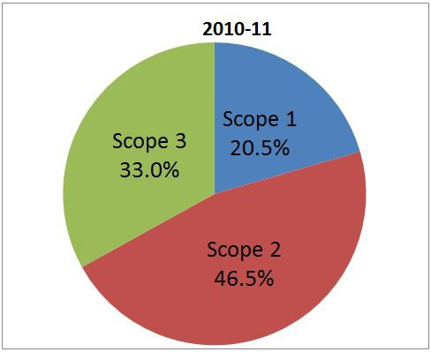

Figure 2: 2010-­‐2011 Emissions by Source The most significant Scope 1 emissions are from Other On-­‐Campus

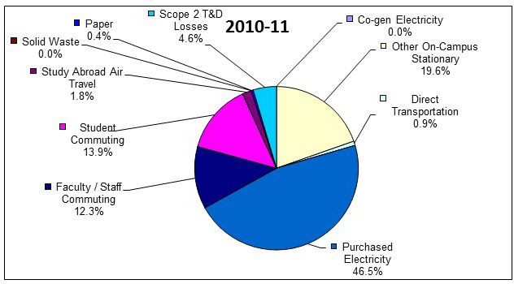

Stationary, which includes distillate oil and natural gas. It makes up 19.6% of total emissions and is equivalent to 2044.8 MTeCO2. Overall Scope 1 emissions made up 20.5% of overall emissions and are equivalent to 2134.9 MTeCO2.
Scope 2 emissions consist solely of purchased electricity, which makes up 46.5% of total emissions and is equivalent to 4839.4 MTeCO2. The majority of our mitigation strategies aim to decrease our electricity emissions since it is such a significant part of LVC’s carbon footprint.
Scope 3 emissions contribute 33% of total emissions or 3442.2 MTeCO2. Student commuting makes up 13.9% of Scope 3 emissions and contribute 1450.2 MTeCO2 .

Figure 3: Total Emissions Reductions from 2008-­‐2011

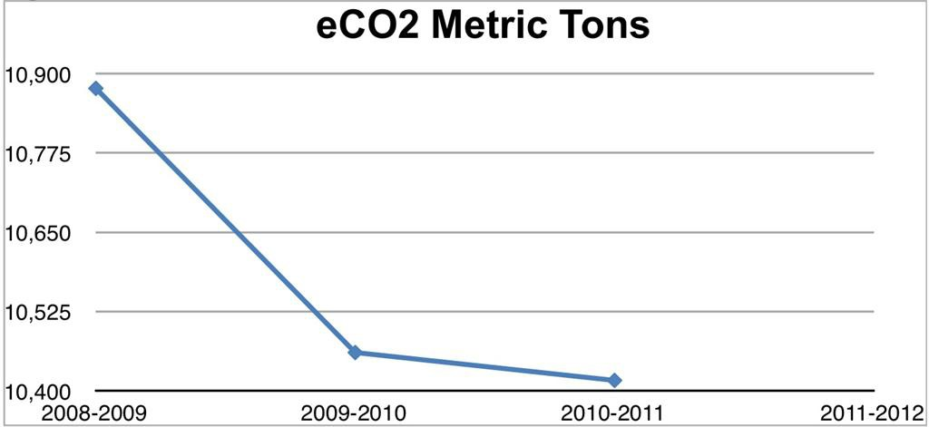
Figure 4: Total Reductions by Scope/Source and Percent Changes from 2008-­‐ 2011

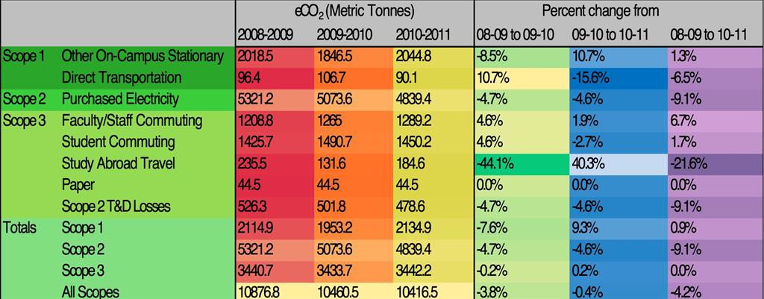
In Figure 4, the darker the color means the lower the value. Therefore, the dark cells are those which have decreased the most and are produced the least. On the right side labeled “Percent change from” we have constructed percent values for how much Lebanon Valley College has reduced certain scopes compared to previous Carbon Footprint Reports the college has prepared.

