Carbon Footprint 2011-­‐2012
During the 2012-­‐2013 school year, a carbon inventory was completed for the 2011-­‐2012 fiscal year. In the program this is designated as 2011-­‐2012 Report. The program breaks down emissions into three categories: Scope 1, Scope 2, and Scope 3.

Scope 1 emissions are direct emissions that come from sources that are owned and/or controlled by Lebanon Valley College. LVC has complete control over these emissions such as the fossil fuel combustion of campus fleet vehicles. These are the direct responsibility of the college. Scope 1 emissions for LVC result from fossil fuel and fertilizer usage. The campus uses natural gas and distillate oil for heating buildings; most buildings use natural gas. Diesel fuel and unleaded gasoline used for running the college fleet also fall into the scope 1 category. Refrigerants and other chemicals would be another source of scope 1 emissions, but the college ensures that these chemicals are properly cared for and not released as emissions.

Scope 2 emissions are indirect emissions from sources that are not owned or operated by Lebanon Valley College. However, these sources are directly linked to the energy used by the campus. While the college is not of direct responsibility of these emissions, it is the fault of the college for the need of these emissions due to demand. For Lebanon Valley College, purchased electricity is the only source of scope 2 emissions. The monthly records for electricity purchases is available from the office of Facility Services and is also among the publicly available spreadsheets provided in the department’s public drive.

All other emissions are attributed to the Scope 3 category. These emissions are typically considered as “optional” and are harder to classify. Either these emissions are the result of direct financing or encouragement of the college, but are not from sources owned or operated by LVC. Some great examples of this would be study abroad travel and faculty, staff and student commuting. The responsibility of these emissions is unclear but must be carefully monitored in order to ensure the emissions are not counted twice.

After gathering all the necessary data, the Campus Carbon Calculator was used to analyze the emissions produced by Lebanon Valley College.

Carbon Inventory Results Summary
Before any mitigation strategies, total emissions from all three scopes were 10362.7 MTeCO2, or metric tons of Carbon Dioxide Equivalents. Figure 1, below, shows the breakdown of total emissions by scope and Figure 2 provides a more detailed breakdown of emissions by sources. The Scope 2 emissions category accounts for nearly half of total emissions. The final figures display the total amount of MTeCO2 reduced since 2008 as well as some percentage changes from 2008 to 2012.

Figure 1: 2011-­‐2012 Emissions by Scope

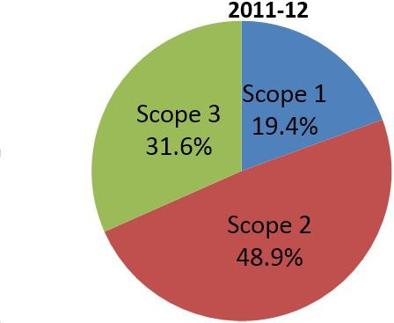

Figure 2: 2011-­‐2012 Emissions by Source
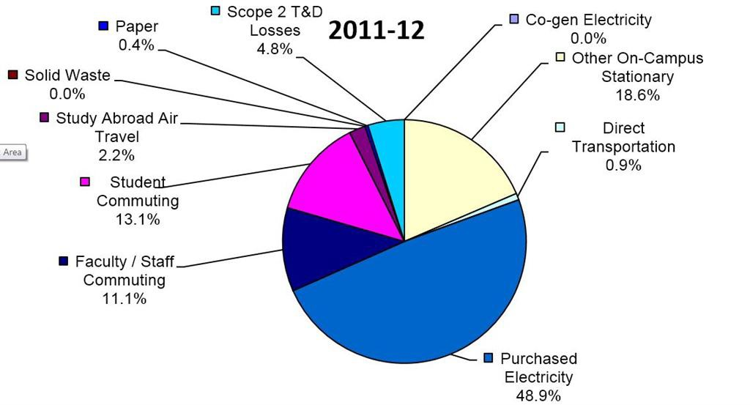

The most significant Scope 1 emissions, producing 2012.1 MTeCO2, are from Other On-­‐Campus Stationary, which includes distillate oil and natural gas mainly used for heating campus buildings. Approximately 95% of Scope 1 emissions is attributed to Other On-­‐Campus Stationary and also makes up 19.4% of total emissions. Overall Scope 1 emissions made up 20.3% of overall emissions and are equivalent to 2104.5 MTeCO2.
Scope 2 emissions consist solely of purchased electricity, which makes up 47.4% of total emissions and is equivalent to 4909.8MTeCO2. The majority of our mitigation strategies aim to decrease our electricity emissions since it is such a significant part of LVC’s carbon footprint.
Scope 3 emissions contribute 32.3% of total emissions or 3348.4 MTeCO2. The main contributor to Scope 3 emissions is student and faculty commuting. Student commuting makes up 39.7% of Scope 3 emissions, with 1330.8 MTeCO2, and 12.8% of total emissions.

Figure 3: Total Emissions Reductions from 2008-­‐2012

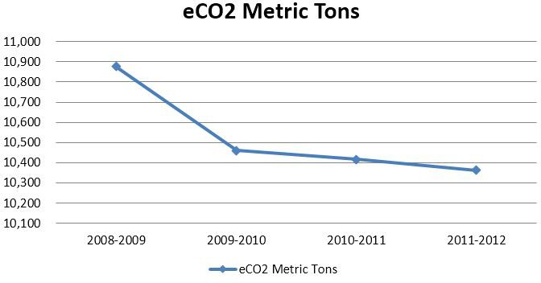

Figure 4: Reduction Percentages from 2008-­‐2012 by Scope/Source

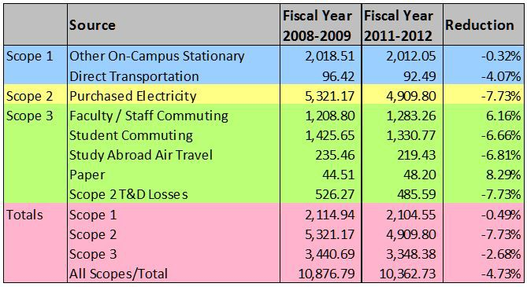
Figure 4 focuses primarily on the progress of Lebanon Valley College from the beginning of fiscal year 2008-­‐2009 to the end of fiscal year 2011-­‐2012. Many of the sources have decreased around six and seven percent. The college has decreased emissions from each source except faculty/staff commuting and paper. The graph below graphically explains this trend with the sudden spike that occurred between fiscal year 2008-­‐2009 and fiscal year 2009-­‐2010. Then there was only a slight increase and now the emissions have leveled out and have even decreased slightly. The 8 percent increase in paper has been addressed this year by implementing an allowance system among the students. Each student is allowed a certain number of pages and once that limit is approached the student will need to pay for additional pages. The college hopes this allowance system offers incentives for students to think twice before printing and lower overall paper usage.

Figure 5: Faculty/Staff Commuting Trend from 2008-­‐2012

1,300
_{Ill} 1,280
C:
Faculty/Staff Commuting

1,260
/
/

I.I
·;:: 1,240
+-'
Q)
1,220
N 1,200
0
u

Q) 1,180
1,160

2008-2009 2009-2010 2010-2011 2011-2012
Fiscal Year

