Carbon Footprint 2012-­‐2013
During the 2013-­‐2014 school year, a carbon inventory was completed for the 2012-­‐2013 fiscal year using the web-­‐based Campus Carbon Calculator (Carbon Management and Analysis Platform (CarbonMAP) powered by Sightlines.) The application breaks down emissions into three categories: Scope 1, Scope 2, and Scope 3.

Scope 1 emissions are direct emissions that come from sources that are owned and/or controlled by Lebanon Valley College. Scope 1 emissions for LVC result from fossil fuel and fertilizer usage. The campus uses natural gas and distillate oil for heating buildings with most buildings using natural gas. Diesel fuel and unleaded gasoline used for running the college fleet also fall into the Scope 1 category.
Refrigerants and other chemicals would be another source of Scope 1 emissions, but the college ensures that these chemicals are properly cared for and not released as emissions.

Scope 2 emissions are indirect emissions from sources that are not owned or operated by Lebanon Valley College. However, these sources are directly linked to the energy used by the campus. While the College is not directly responsible for these emissions, the College requires this energy to operate and is responsible for the demand. For Lebanon Valley College, purchased electricity is the only source of scope 2 emissions. A new initiative for Lebanon Valley College during this reporting year was the switch to 100% purchased wind electricity. This great initiative has resulted in a significant drop in Scope 2 emissions to practically zero.

Scope 3 emissions are all other emissions. These emissions are typically considered as “optional” and are harder to classify. Either these emissions are the result of direct financing or encouragement of the College, but are not from sources owned or operated by LVC. Some examples of this would be study abroad travel and faculty, staff and student commuting. The responsibility of these emissions is unclear but must be carefully monitored in order to ensure the emissions are not counted twice.

CARBON INVENTORY RESULTS SUMMARY
- Before any mitigation strategies, total emissions from all three scopes were 5,795.59 MTeCO2, or Metric Tons of Carbon Dioxide Equivalents.
- Figure 1, below, shows the breakdown of total emissions by scope.
- Figure 2 provides a more detailed breakdown of emissions by sources.
- Due to the College purchasing 100% wind-­‐generated electricity, Scope 2 emissions have been virtually eliminated and reduced the College’s Carbon Footprint 4,908 MTeCO2. Last year, this category accounted for nearly half of the college’s total emissions.

Figure 1: 2012-­‐2013

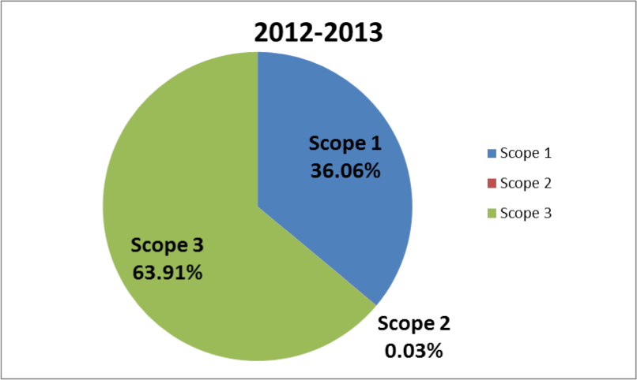

Emissions by Scope

Figure 2: 2012-­‐2013 Emissions by Source

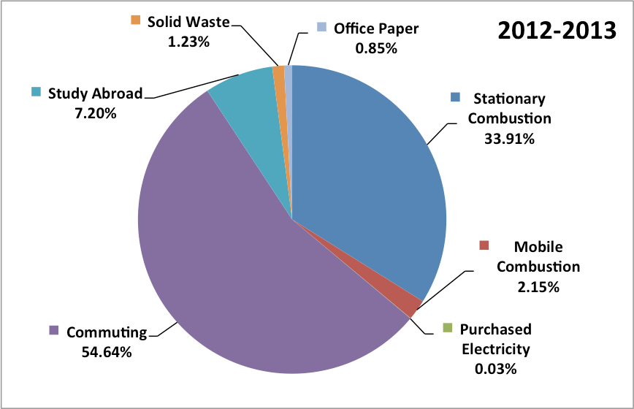

The most significant Scope 1 emissions, producing 1,965.16 MTeCO2, are from Stationary Combustion, which includes distillate oil and natural gas mainly used for heating campus buildings; this number has decreased from previous years.
Approximately 94% of Scope 1 emissions is attributed to Stationary Combustion and also makes up 33.91% of total emissions. Overall Scope 1 emissions made up 36.06% of overall emissions and are equivalent to 2,089.84 MTeCO2.
Scope 2 emissions consist solely of purchased electricity, which makes up 0.03% of total emissions and is equivalent to 1.65 MTeCO2. In the past, the majority of our mitigation strategies were aimed at decreasing the electricity emissions since it was such a significant part of LVC’s carbon footprint and the college was extremely successful.
Scope 3 emissions contribute 63.91% of total emissions or 3,704.11 MTeCO2. The main contributor to Scope 3 emissions is student, faculty and staff commuting making up 85% of Scope 3 emissions, with 3,166.67 MTeCO2, and 54.64% of total emissions.

The increase in emissions from commuting is largely due to more students commuting and now makes up a greater percentage of the total emissions. Another source of emissions that has been growing is Study Abroad. Again this increase is largely due to the fact that more students have been participating in this great opportunity.

