Carbon Footprint 2013-­‐2014
During the 2014-­‐2015 school year, a carbon inventory was completed for the 2013-­‐2014 fiscal year using the web-­‐based Campus Carbon Calculator (Carbon Management and Analysis Platform (CarbonMAP) powered by Sightlines.) The application breaks down emissions into three categories: Scope 1, Scope 2, and Scope 3.

Scope 1 emissions are direct emissions that come from sources that are owned and/or controlled by Lebanon Valley College. Scope 1 emissions for LVC result from fossil fuel and fertilizer usage. The campus uses natural gas and distillate oil for heating buildings with most buildings using natural gas. Diesel fuel and unleaded gasoline used for running the college fleet also fall into the Scope 1 category.
Refrigerants and other chemicals would be another source of Scope 1 emissions, but the college ensures that these chemicals are properly cared for and not released as emissions.

Scope 2 emissions are indirect emissions from sources that are not owned or operated by Lebanon Valley College. However, these sources are directly linked to the energy used by the campus. While the College is not directly responsible for these emissions, the College requires this energy to operate and is responsible for the demand. For Lebanon Valley College, purchased electricity is the only source of scope 2 emissions.

Scope 3 emissions are all other emissions. These emissions are typically considered as “optional” and are harder to classify. Either these emissions are the result of direct financing or encouragement of the College, but are not from sources owned or operated by LVC. Some examples of this would be study abroad travel and faculty, staff and student commuting. The responsibility of these emissions is unclear but must be carefully monitored in order to ensure the emissions are not counted twice. During this reporting year, we have decided to account for sports travel via bus and van. This has resulted in a slight increase in Scope 3 emissions as well as a more accurate carbon footprint.

Carbon Inventory Results Summary
- Before any mitigation strategies, total emissions from all three scopes were 6,094.38 MTeCO2, or Metric Tons of Carbon Dioxide Equivalents.
- Figure 1, below, shows the breakdown of total emissions by scope.
- Figure 2 provides a more detailed breakdown of emissions by sources.
- Due to the College purchasing 100% wind-­‐generated electricity, Scope 2 emissions have been completely eliminated. Last year, this category accounted for .03% of the college’s total emissions.

Figure 1: 2013-­‐2014 Emissions by Scope

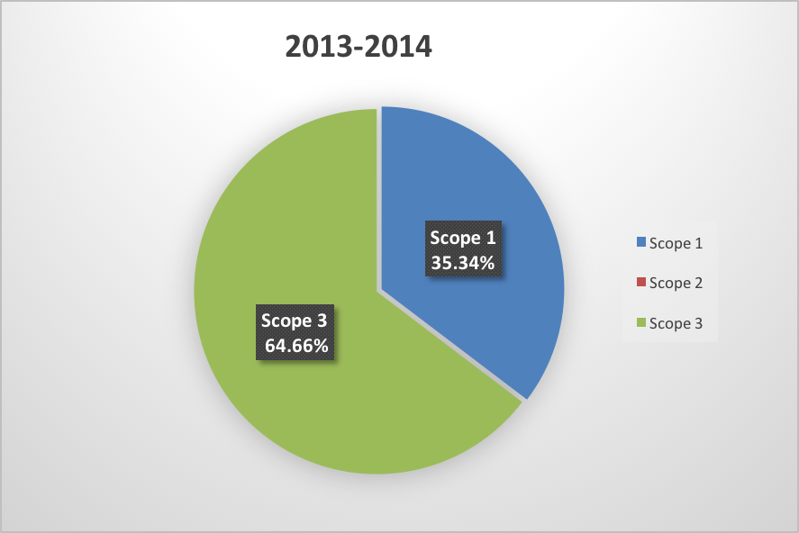

Figure 2: 2013-­‐2014 Emissions by Source
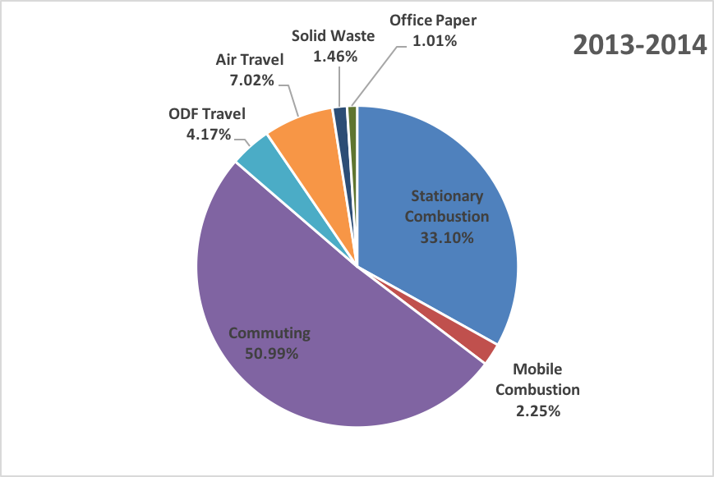

The most significant Scope 1 emissions, producing 2,017.02MTeCO2, come from Stationary Combustion, which includes distillate oil and natural gas mainly used for heating campus buildings; this number is slightly lower compared to last year, but there is no significant change. Approximately 93.65% of Scope 1 emissions is attributed to Stationary Combustion and also makes up 33.1% of total emissions.
Overall Scope 1 emissions made up 35.34% of overall emissions and are equivalent to 2,153.88 MTeCO2.
Scope 2 emissions consist solely of purchased electricity, which makes up 0 % of total emissions. In the past, the majority of our mitigation strategies were aimed at decreasing the electricity emissions since it was such a significant part of LVC’s carbon footprint and the college was extremely successful.
Scope 3 emissions contribute 64.66% of total emissions or 3,940.51 MTeCO2. The main contributor to Scope 3 emissions is student, faculty, and staff commuting making up 78.86% of Scope 3 emissions, with 3,107.52 MTeCO2, and 50.99% of total emissions.

Figure 3: Total Emissions Reductions from 2008-­‐2014
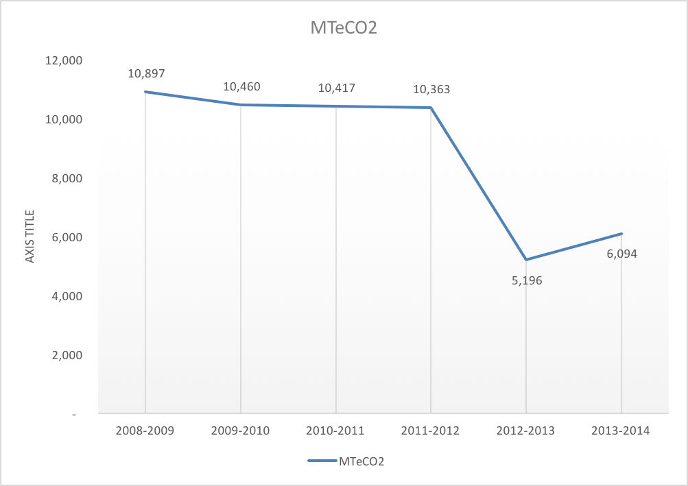

Table 1: Reduction Percentages from 2008-­‐2014 by Scope/Source
Source |  | 2008-­‐  2009  Fiscal Year | 2013-­‐  2014  Fiscal Year | Increase/ Decrease
Scope 1 | Other On-­‐Campus Stationary | 2,018.51 | 2,017.02 | -­‐0.07%

 | Direct Transportation | 96.42 | 136.85 | 41.93%
Scope  2 | Purchased Electricity | 5,321.17 | 0.00 | -­‐100.00%
Scope  3 | Faculty / Staff Commuting | 1,208.80 | 3,107.52 | 17.96%
 | Student Commuting | 1,425.65
 | Study Abroad Air Travel | 235.46 | 428.10 | 81.81%
 | Paper | 44.51 | 61.66 | 38.53%
 | Scope 2 T&D Losses | 526.27 | 0.00 | -­‐100.00%
Totals | Scope 1 | 2,114.94 | 2,153.88 | 1.84%
 | Scope 2 | 5,321.17 | 0.00 | -­‐100.00%
 | Scope 3 | 3,440.69 | 3,940.50 | 14.53%
 | All Scopes/Total | 10,876.79 | 6,094.38 | -­‐43.97%

Conclusion

Total emissions increased by 298.91 MTeCO2 from the previous fiscal year, however, 253.94 MTeCO2 of these emissions can be attributed by athletic travel, which has not been previously reported. Therefore, there is not a significant difference in overall carbon emissions compared to the 2012-­‐2013 fiscal year. In addition, Scope 2 T&D Losses for the 2013-­‐2014 fiscal year are zero, because they are now negligible; this is due to the college’s use of wind-­‐renewable energy. We also noticed that the college is no longer purchasing paper with a percentage of recycled content. We recommend the College once again purchase paper made from recycled content.

