Carbon Footprint 2016-2017

During the 2017-2018 school year, a carbon inventory was completed for the 2016- 2017 fiscal year. In the SIMAP program, this is designated as 2016-2017 Report.

The program breaks down emissions into three categories: Scope 1, Scope 2, and Scope 3.

Scope 1 emissions are direct emissions that come from sources that are owned and/or controlled by Lebanon Valley College. LVC has complete control over these emissions such as the fossil fuel combustion of campus fleet vehicles. These are the direct responsibility of the college. Scope 1 emissions for LVC result from fossil fuel and fertilizer usage. The campus uses natural gas and distillate oil for heating buildings; most buildings use natural gas. Diesel fuel and unleaded gasoline used for running the college fleet also fall into the scope 1 category. Refrigerants and other chemicals would be another source of scope 1 emissions, but the college ensures that these chemicals are properly cared for and not released as emissions.

Scope 2 emissions are indirect emissions from sources that are not owned or operated by Lebanon Valley College. However, these sources are directly linked to the energy used by the campus. While the college is not of direct responsibility of these emissions, it is the fault of the college for the need for these emissions due to demand. For Lebanon Valley College, purchased electricity is the only source of scope 2 emissions. The monthly records for electricity purchases is available from the office of Facility Services and is also among the publicly available spreadsheets provided in the department’s public drive.

All other emissions are attributed to the Scope 3 categories. These emissions are typically considered as “optional” and are harder to classify. Either these emissions are the result of direct financing or encouragement of the college but are not from sources owned or operated by LVC. Some great examples of this would be study abroad travel and faculty, staff, and student commuting. The responsibility of these emissions is unclear but must be carefully monitored in order to ensure the emissions are not counted twice.

After gathering all the necessary data, The University of Connecticut’s Sustainability Indicator Management and Analysis Platform (SIMAP) was used to analyze the emissions produced by Lebanon Valley College in FY 16-17.

Methodology
After gathering all the necessary data, The University of New Hampshire’s Sustainability Indicator Management and Analysis Platform (SIMAP) was used to analyze the emissions produced by Lebanon Valley College in FY 16-17.

Data Collection
Data regarding the three scopes is collected from corresponding departments on LVC’s campus. This data is collected, then inputted into SIMAP. Data is collected by fiscal year. The FY 16-17 report includes information from July 1st, 2016 until June 31st, 2017.
Assumptions
Scope 1: The conversion from MCFs to MMBtu used is 1.0372 MMBtu = 1 Mcf.

Scope 2: Lebanon Valley College successfully transitioned to wind energy as a full source of electricity in FY 13-14. Thus, Scope 2, which accounts all usage of a renewable energy source reports no carbon consumption.

Scope 3: Commuting data FY 12-13 until FY 15-16 comes from FY 12-13 with the assumption that there was little change within that five-year period. Faculty and Staff commuting data is broken down into full- time and part-time faculty and staff (indicators are noted in SIMAP). It is assumed that part-time faculty commute 6 trips per week for 30 weeks per year. Full-time faculty are assumed to commute 10 trips per week, 30 weeks per year. Part-time staff are assumed to commute 6 trips per week, 48 weeks per year. Full-time staff are assumed to commute 10 trips per week, 48 weeks per year. 48 weeks per year given that out of the 52 weeks per week, approximately 4 weeks per year are vacation for staff (full and part- time). Full-time residential students are accounted for under “Student Travel to and from Home” in Scope 3. “Student commuting” represents only students commuting to LVC daily. All commuting data lies under the assumption that all commuters commute via automobile.

Paper consumption data takes the following assumptions for weight of paper: 500 envelopes = 7.44 lbs.
500 sheets of letterhead = 6 lbs.
500 sheets of multipurpose paper = 4.96 lbs. 500 sheets of card stock = 11.5 lbs.

Business Travel and Study Abroad includes charter bus travel for athletics as well as student air travel for study abroad programs. Athletic travel maintains the assumption that all travel is done by diesel charter bus and that the bus takes the same, most fuel-efficient route to and from LVC.

Limitations
FY 16-17 is the first year to use SIMAP to calculate LVC’s carbon footprint. Transferring old data from the previous carbon calculating platform to SIMAP resulted in several inconsistencies, especially in the third scope. Specifically, the faculty and student commuting data posed several limitations. First, commuting data (faculty, staff, and students) from previous years was unable to be imported into the SIMAP calculator. Second, SIMAP makes distinctions between full-time, residential students and part-
time/commuter students. Thus, previous years’ data was misconstrued in the SIMAP program. Third, SIMAP allows the user to make an important commuting distinction between full-time and part-time faculty and staff. Thus, this lead to an establishment of new assumptions, noted in the methodology.

Thus, FY16-17 shows a vast decrease in Scope 3 from previous years (which can be seen in Figure 3). This is due to a change in assumptions and methodology. Future calculations in SIMAP of Scope three under the new assumptions will be more precise.

Carbon Inventory Results Summary
The total emissions for FY 2016-2017 for all three scopes were 5,749,228 kg CO2. Figure 1 displays the breakdown of emissions by scope. Scope 2 was eliminated in its entirety in FY 2013-2014 when Lebanon Valley College switched to purchasing 100% wind electricity. Figure 2 displays a more detailed breakdown of LVC’s carbon emissions by specific category. Figure 3 displays the progress of LVC’s commitment to reducing its carbon footprint from 2010 until 2017.

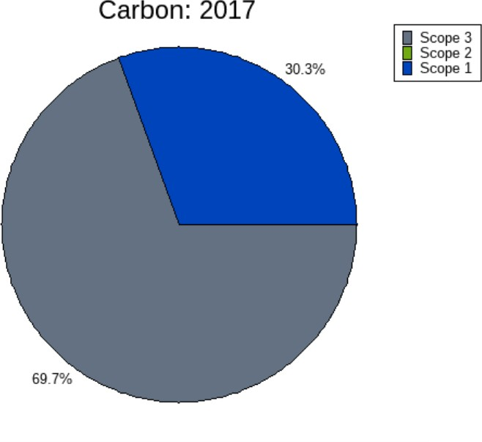
Figure 1: Lebanon Valley College Carbon Emissions 2017

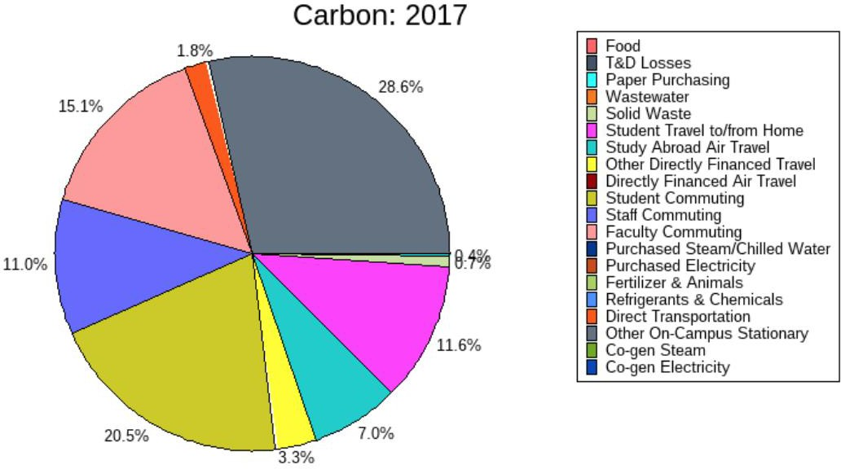

Figure 2: Breakdown of Lebanon Valley College Carbon Emissions 2017

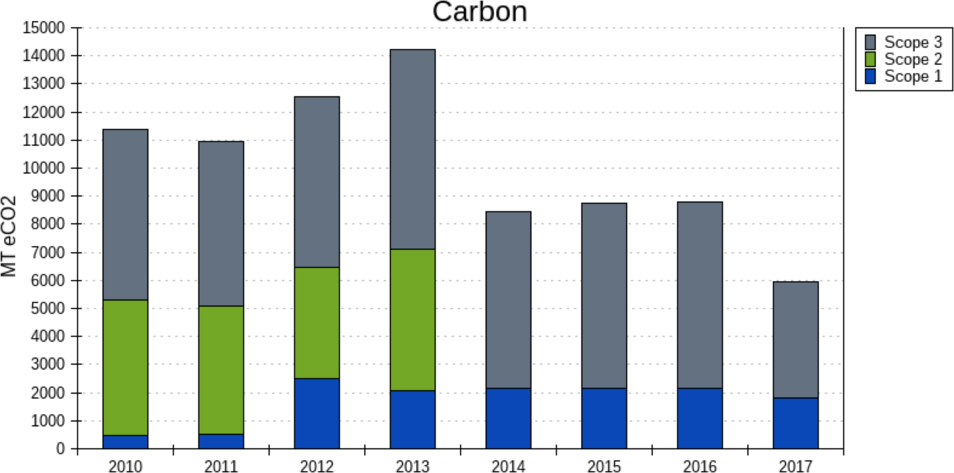

Figure 3: Lebanon Valley College Carbon Emissions 2010-2017

