Carbon and Nitrogen Footprint 2017-2018

During the 2018-2019 school year, a carbon and nitrogen inventory was completed for the 2017-2018 fiscal year. In the SIMAP program, this is designated as 2017-2018 Report.

The program breaks down carbon emissions into three categories: Scope 1, Scope 2, and Scope 3.

During the 2018-2019 school year, a carbon and nitrogen inventory was completed for the 2017-2018 fiscal year using the web-based campus ecological footprint calculator University of New Hampshire’s Sustainability Indicator Management and Analysis Platform (SIMAP). The application breaks down emissions into three categories: Scope 1, Scope 2, and Scope 3.

Scope 1 emissions are direct emissions that come from sources that are owned and/or controlled by Lebanon Valley College. Scope 1 emissions for LVC result from fossil fuel and fertilizer usage. The campus uses natural gas for most of its heating needs and distillate oil for a few campus-owned houses. Diesel fuel and unleaded gasoline used for running the college fleet also fall into the Scope 1 category. Refrigerants and other chemicals would be another source of Scope 1 emissions, but the college ensures that these chemicals are properly cared for and not released as emissions. Additionally, in the carbon footprint for FY 17-18, we included fertilizer-based emissions for the first time.

Scope 2 emissions are indirect emissions from sources that are not owned or operated by Lebanon Valley College. However, these sources are directly linked to the energy used by the campus. While the College is not directly responsible for these emissions, the College requires this energy to operate and is responsible for the demand. For Lebanon Valley College, purchased electricity is the only source of scope 2 emissions.

Scope 3 emissions are all other emissions. These emissions are typically considered as “optional” and are harder to classify. Either these emissions are the result of direct financing or encouragement of the College but are not from sources owned or operated by LVC. Some examples of this would be study abroad travel and faculty, staff and student commuting, sports travel, solid waste, wastewater, and paper usage. The responsibility of these emissions is unclear but must be carefully monitored in order to ensure the emissions are not counted twice. Additionally, this year is the first year we have calculated food consumption as part of the carbon and nitrogen footprint. This has resulted in a drastic increase in scope 3.

Methodology
Summation of the three scopes minus offsets produces an estimated amount of carbon emitted. Data
regarding the three scopes is gathered from corresponding departments on LVC’s campus. This data is

collected, documented, then inputted into SIMAP. Data is collected by fiscal year. The FY 17-18 report includes information from July 1st, 2017 through June 31st, 2018.
Scope 1

Stationary and Transport Fuels Emissions
Scope 1, in LVC’s carbon and nitrogen footprint, is broken down into two categories of direct emissions within SIMAP: on-campus stationary fuels and direct transportation fuels. On-campus stationary fuels refer to the means in which the campus produces its own heat. LVC does not co-generate its heat and electricity. Direct transportation fuels refer to fuel consumed by college fleet vehicles, such as the fuel used by LVC Public Safety’s truck or by college-owned maintenance vehicles. While SIMAP accounts for a variety of stationary and direct transport fuels, LVC relies primarily on natural gas, distillate oil (#1-4), and LPG (propane) for its stationary fuel needs. Natural gas is the primary source of heating for the majority of LVC’s campus, while distillate oil is used in a smaller number of on-campus houses. LVC uses primarily diesel and gasoline for its direct transport fuel needs.

Fertilizers and Animal Associated Emission
LVC does not own or operate farm land, however, LVC utilizes both synthetic and organic fertilizers to maintain the campus’s grounds. LVC uses three types of fertilizers from two brands with three different nutrient ratios: Proscape, a synthetic fertilizer with a 16% nitrogen content, and Earthworks, an organic fertilizer with both 8% and 5% nitrogen content. To account for nitrogen pollution from fertilizers, the used weights of the three fertilizers were summed, and each fertilizer was accounted for separately based on whether it was synthetic, organic, and the ratio of nitrogen in the fertilizer. The resulting amount of nitrogen pollution is calculated in SIMAP through the evaluation of the fertilizer’s weight and nitrogen ratio. SIMAP accounts for animal nitrogen emissions, as well. However, Lebanon Valley College does not own or operate farmland and livestock; therefore, the carbon or nitrogen footprint of LVC does not account for animal-based emissions.
Scope 2
In FY 2013-2014, LVC switched from purchasing traditional energy to purchasing renewable energy credits from Constellation energy company (a branch of Exelon energy company) to support wind electricity.⁶ Because wind is a renewable energy source, the quantity of wind electricity purchased in a given fiscal year does not contribute emissions towards LVC’s carbon and nitrogen footprint. Therefore, Scope 2 represents zero nitrogen emissions in every fiscal year since FY 13-14. However, LVC continues to report its electricity consumption to maintain its total energy consumption records in SIMAP.
Scope 3
Scope 3 accounts for four major sources of carbon and nitrogen emissions: faculty, staff, and student commuting and travel, food consumption, all campus waste disposal, and paper consumption. Emissions from scope 3 activities, primarily food consumption, attribute most to LVC’s nitrogen footprint.

Commuting
The emissions associated with the regular commuting of LVC’s faculty, staff, and students represent a notable amount of annual carbon and nitrogen emissions.¹³ SIMAP requires a calculated average for the commutes of the all members of LVC’s community. Therefore, a number of assumptions are made to estimate an average commute for each group of commuters. The following assumptions were updated for the FY 16-17 carbon footprint calculation. All commuters in the commuting section of SIMAP are assumed to use automobile as their primary mode of transportation, due to the general lack of public transportation resources near and around Annville, Pennsylvania, where Lebanon Valley College is located. Dates of changes of specific assumptions are noted in SIMAP. The assumptions made from FY 16- 17 forward are noted below.

Faculty Commuting. Faculty commuting is divided into part-time and full-time faculty members. Full-time faculty are assumed to commute 10 trips per week, to and from LVC, 30 weeks per year. It is assumed that part-time faculty commute 6 trips per week for 30 weeks per year. Summertime faculty are not considered in this calculation.
Staff Commuting. Staff commuting assumptions is divided into part-time and full-time staff members. Full-time staff are assumed to commute 10 trips per week, 48 weeks per year. Part-time staff are assumed to commute 6 trips per week, 48 weeks per year. Full-time staff are assumed to commute 10 trips per week, 48 weeks per year48 weeks per year given that out of the 52 weeks per week, approximately 4 weeks per year are considered vacation for staff (full and part-time).
Student Commuting and Travel. Student transportation emissions are assessed based on whether the student is a residential student, meaning that the student lives on campus the major of the academic year, or a commuter student, meaning that the student lives within a 30-mile radius of LVC and drives to and from the college for their classes. Full-time residential students are accounted for under “Student Travel to and from Home” in Scope 3. “Student commuting” represents only students commuting to LVC daily. All commuting data lies under the assumption that all commuters commute via automobile, except for students who study abroad, which are accounted for under Study Abroad and Athletic Travel.

Study Abroad and Athletic Travel
Students who study abroad are accounted for by determining their flight and travel distances to and from LVC. This assumes all students who studied outside of the United States for a semester or more used air travel as their means of travel. Student athletic travel, which is included in Scope 3 as well, assumes that all athletes travel to their events on the same diesel buses, with their entire team on the same bus, and that the buses always take the most efficient route to and from their destination.

Food Consumption
Food consumption contributes greatly to LVC’s overall carbon and nitrogen footprint. The carbon food footprint is determined through an emissions factor of CO2 per kg of food consumed. The nitrogen footprint of food is determined by two main factors in SIMAP: nitrogen losses from food consumption and nitrogen losses in food production. These categories are determined through the summation of virtual nitrogen losses, transportation emissions, and food waste. Virtual nitrogen is calculated by multiplying a virtual nitrogen factor by the weight of the food in a given food category. Transportation emissions are determined through average food miles, based on whether the food is considered local or nonlocal. Food waste is given by average food waste in the United States per pound of food purchased (Leach, Rothenberg, and Andrews 2018; Leach et al. 2017). In order to assess the contribution of food to LVC’s nitrogen footprint, campus eating situations were first assessed. LVC, despite being a small institution, acts as a major food distributor to nearly 1,600 undergraduate students as well as several graduate students, faculty, and staff members. Most students are considered full-time residential students and utilize LVC’s dining services as their primary source of food consumption during the academic year. All food services at LVC are provided through Metz Culinary Management, Inc., operating five dining options on campus to students: Mund Dining Hall, Intermetzo, Dutchman Den, Bishop Brews, and the Grove Express.
Records of all of LVC’s food purchases were retrieved from Metz Culinary Management (Metz) for FY 17-
18. All data was compiled into a food purchase inventory and associated net weights that were not provided by Metz were calculated based on weight assumptions.⁷ After all food purchases were accounted for FY 17-18, each food was assigned one of the following categories, based on the primary ingredient of the food product: beef, pork, chicken, cheese, eggs, milk, seafood, liquids/beverages, grains, fruits, vegetables, nuts, oils, beans, spices, potatoes, stimulants (coffee, teas, chocolates), and sugars (Leach,

Rothenberg, and Andrews 2018). Foods considered “milk” included milk (2% and whole milk), chocolate milk, ice cream, creamers for coffee, and buttermilk. In addition to each food product being assigned a primary food category, all food products were also assigned secondary and tertiary categories if the food was considered a multi-ingredient food by SIMAP.
After each food product was assigned a category, each food product was designated as either “local” or “nonlocal.” Local foods are defined as foods that were grown and/or produced within a 200-mile radius of where they are ultimately consumed. Metz provided data as to which food products were considered “local” or not, based on the location of their various suppliers. However, Metz does not purchase organic foods to serve in its dining locations, so the “organic” designation could be made for no food products in SIMAP. All food categories, their associated weights, and whether the food is considered local or not are entered into SIMAP.

Campus Waste Disposal
Campus Solid Waste Disposal. SIMAP assesses both the category and source of the institution’s waste production, attaching a numerical value of carbon and nitrogen emissions, based on the quantity of waste produced. At LVC, waste that is not diverted to recycling, which is not accounted for by SIMAP, is designated as landfill waste, with methane (CH4) recovery and flaring. Based on an average composition of waste and average emissions factor, SIMAP determines the average emissions per short ton of solid waste.

Campus Wastewater Disposal. Campus wastewater disposal was calculated in place of solid waste disposal all years prior to FY 12-13. LVC’s waste water is treated at an aerobic central treatment system. An aerobic system is a secondary water treatment system where aerobic bacteria break down human excreta in circulated oxygen.

Paper Consumption
Paper is divided into two source categories: coated freesheet and uncoated freesheet. Coated freesheet refers to paper that is glossy, such as cover gloss paper. Uncoated freesheet refers to all other types of paper including letterhead and envelopes. Each type of paper consumed by LVC is categorized by whether it is coated or not and then by its percentage of recycled contents.
LVC tracks its annual paper consumption by pages used; however, SIMAP calculates the footprint of paper consumption by weight of all paper consumed. In order to convert the number of sheets used to a weight, assumed weights are used for the various types of paper. Paper is assumed to only be a part of the carbon footprint.

Results
In FY 17-18 LVC was responsible for 6,940.21 GHG MTCDE and 19.43 MT of N.

Scope 2
In FY 13-14, LVC switched from purchasing traditional electricity from local electricity suppliers to purchasing 100% renewable energy credits from Constellation, an Exelon company, for alternative energy solutions. Starting in the 2012-2013-year, LVC began purchasing electric power created entirely by wind turbines, lowering the average emissions for 2012-2016 to 5,460 metric tons, resulting in a
reduction of 48%. This purchase reduced LVC’s carbon footprint by nearly one half and greatly impacted LVC’s nitrogen footprint. This information is available in more detail on LVC’s website under
“Sustainability Initiatives” and “Annual Reports, FY 13-14,” as well as in LVC’s Climate Action Plan.

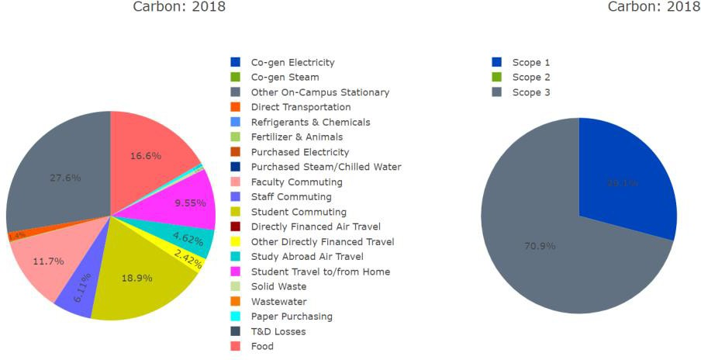

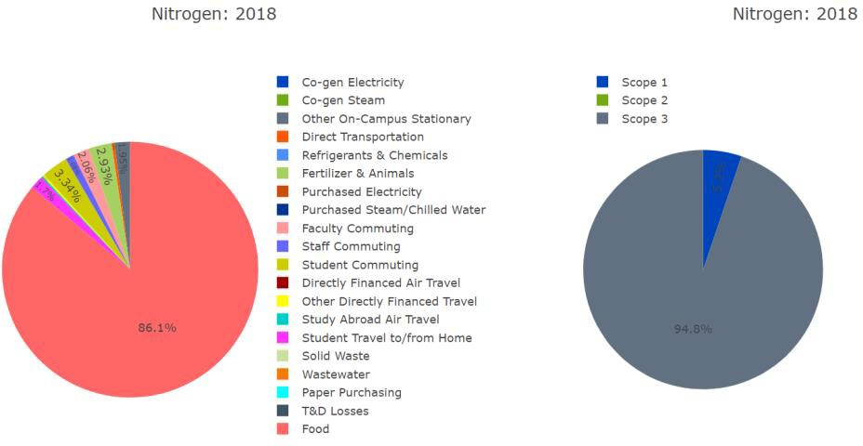

Scope 3: Food Consumption
In FY 18-19, LVC started tracking food consumption on campus to see how it impacted our footprint. This resulted in a drastic increase of recording carbon emissions. Beef, cheese, and chicken are the three categories that account for the most amount of carbon emitted out of all food categories.

