DOCUMENTATION OF CLINICAL HOURS FORM

LEBANON VALLEY COLLEGE
Department of Physical Therapy

TO BE COMPLETED BY STUDENT

Instructions: Complete this section prior to giving it to your supervising physical therapist where you completed your clinical hours. Hours may be volunteer or through employment. All clinical hours must be documented on this form and submitted to the Office of Admission at the time of application to the program. Pre-admission observation requirements: a total of 30 hours of observation.

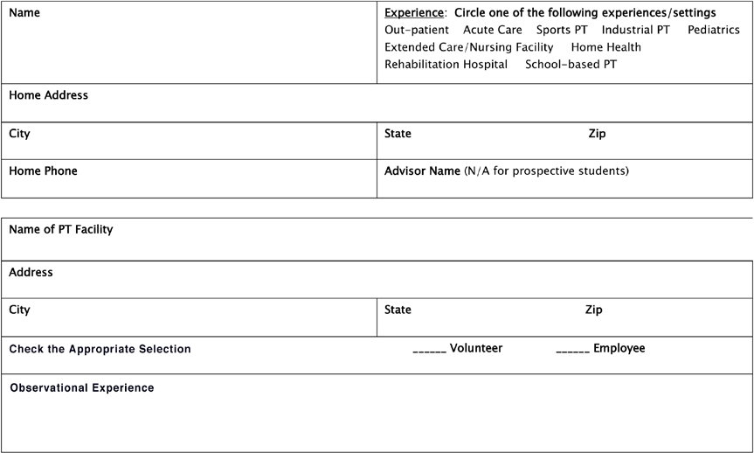

TO BE COMPLETED BY SUPERVISOR
Thank you for allowing our student the observational experience provided.
Instructions: Please verify the facility information above and complete the information below.

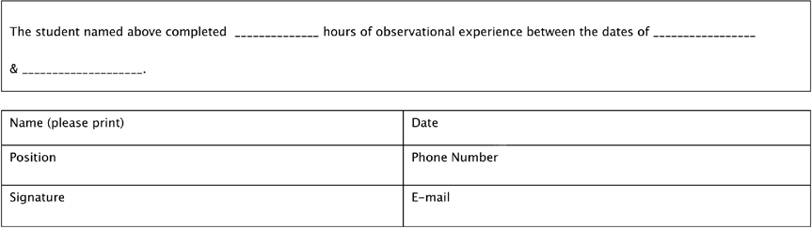

 101 North College Avenue, Annville, PA 17003-1400

