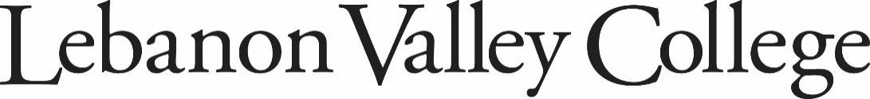

Required Background Checks for All Education Program Students

EARLY CHILDHOOD EDUCATION | EARLY CHILDHOOD EDUCATION/SPECIAL EDUCATION
MUSIC EDUCATION | SECONDARY EDUCATION

All enrolled students in any education program at Lebanon Valley College must complete the following background checks/forms PRIOR to the start of their freshman year.

During the first week of your freshman year, you will need to submit one copy of all three required background checks (clearances) to the Education Department Administrative Assistant. You will not receive a field placement without all three background checks on file. This may result in dropping the course associated with the field placement.

You must keep your originals in plastic sheets to take to the field every semester. No copies will be provided from the Education Department Office.

PLEASE NOTE: To be eligible to begin any field work, observation and/or student teaching, the Pennsylvania Department of Education REQUIRES that all three clearances be completed and on file with your current institution.

New clearances/forms will be required at the beginning of each academic year.

PA CHILD ABUSE HISTORY CLEARANCE (Act 151)  Cost: $13.00  To register:  www.compass.state.pa.us/cwis/Public/home  Reason for request: School Employee Governed by  Public School Code  Sample:  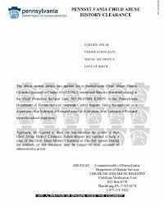 | PA STATE CRIMINAL HISTORY RECORD (Act 34)  Cost: $22.00  To register:  epatch.pa.gov/home  Reason for request: Employment or Other  Sample:  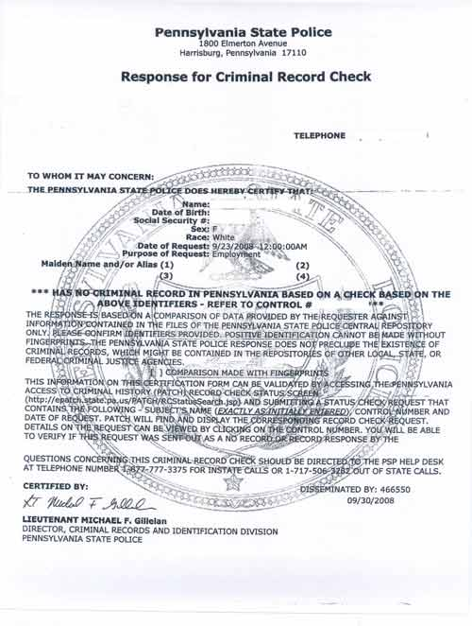
Revised 8/12/24

FEDERAL (FBI) CRIMINAL HISTORY REPORT  (Act 114)  Cost: $23.85  To register:  - Go to:  http://www.identogo.com/locations/pennsylvania  - Select “Digital Fingerprint”  - Type in your service code: 1KG6RT  - On the next screen, select “Schedule or Manage an Appointment.” Complete the registration form,  select a fingerprinting location, select the photo ID you will bring to your appointment (most select Driver’s License), make an appointment or select “walk-in”, pay for the service, and print your  confirmation form. You must print or save as a PDF before you click out of the window or you will be able to retrieve a copy of this clearance.  - Take print out of your registration and your selected photo ID to an IdentoGO fingerprinting site.  - When you receive the email notification from IdentoGO that your clearance results are available,  be sure to access your account from a computer you can save to pdf and print from. Result access is limited to one time only in 30 days. Your link expires 30 days after you receive the email.  - Print your two-page unofficial result.  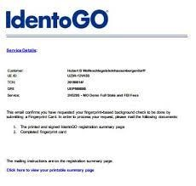 | ARREST/CONVICTION FORM (Act 24)  Cost: $0  This form will be provided in class. Please print and sign your name and submit one copy to the Education Office and retain one copy for your records.  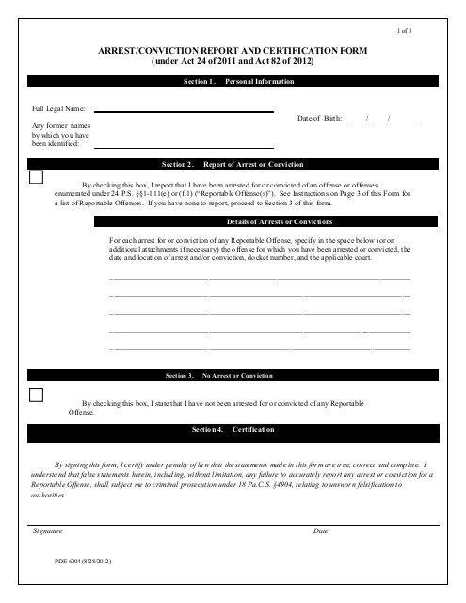  Sample:
TUBERCULOSIS (TB) TEST
Cost: Check Family Doctor

The test may be administered by your family physician. You are responsible for obtaining the test results. Please keep your TB results with your clearances. Some school districts require you to provide proof of the TB test. The education department office does NOT need a copy of your TB test.

Students need a TB test upon entering the education program. Additional tests may be required in future semesters.



Revised 8/12/24

